AUTOMATED BRAIN TUMOR

CLASSIFICATION

###### MIAN MUHAMMAD UMER HASSAN KHAN QURESHI

###### WALEED KHALID



### DEPARTMENT OF COMPUTER SCIENCES

### COMSATS UNIVERSITY ISLAMABAD,

##### ATTOCK CAMPUS – PAKISTAN

# 

# SESSION 2017-2021

**Style Guidelines for Final Year Project Reports****AUTOMATED BRAIN TUMOR**

**CLASSIFICATION**

### *Undertaken By:*

###### MIAN M.UMER HASSAN KHAN QURESHI

CIIT/FA17-BCS-040/ATK

###### WALEED KHALID

CIIT/FA17-BCS-009/ATK

#### Supervised By:

###### MISS SADIA EJAZ

A DISSERTATION SUBMITTED AS A PARTIAL FULFILLMENT OF THE REQUIREMENTS FOR THE DEGREE OF BACHELOR OF SCIENCE IN SOFTWARE ENGINEERING

### DEPARTMENT OF COMPUTER SCIENCES

# 

# COMSATS UNIVERSITY ISLAMABAD,

##### ATTOCK CAMPUS – PAKISTAN

# SESSION 2017-2021

UNDERTAKEN

We certify that this is my/our own work. The work has not, in whole or in part, been presented elsewhere for assessment. Where material has been used from other sources it has been properly acknowledged. If this statement is untrue, we acknowledge that we will have committed an assessment offence and shall be liable to punishable action under the plagiarism rules of HEC.

____________________ ____________________

Mian M.Umer Hassan Khan Qureshi Waleed Khalid

FA17-BCS-040 FA17-BCS-009

Dated: _________ Dated: _________

**FINAL APPROVAL**

Certified that we have read this project report submitted by Mr. (MIAN M.UMER HASSAN KHAN QURESHI/ WALEED KHALID) and it is, in our judgment, of sufficient standard to warrant its acceptance by Department of Computer Science, COMSATS University, Attock, for the (BS degree) in Computer Science.

***Committee:***

1. External Examiner ____________________________

(Examiner Name)

Designation

University Name

2. Supervisor ____________________________

(Supervisor Name)

3. Chairperson ____________________________

(Chairperson Name)

4. Dean/Director ____________________________

(Dean/Director Name)

**DEDICATION**

Thanks to my real and spiritual Parents who provided me the platform, the resources and guidance to understand and complete the project “automated brain tumor classification”.**ACKNOWLEDGEMENT**

All praise is to Almighty Allah who bestowed upon us a minute portion of His boundless knowledge by virtue of which we were able to accomplish this challenging task.

We are greatly indebted to our project supervisor “MISS SADIA EJAZ”. Without her personal supervision, advice and valuable guidance, completion of this project would have been doubtful. We are deeply indebted to them for their encouragement and continual help during this work.

And we are also thankful to our parents and family who have been a constant source of encouragement for us and brought us the values of honesty & hard work.

Student 1 Student 2

____________________ ___________________

**PROJECT BRIEF**

PROJECT NAME AUTOMATED BRAIN TUMOR

CLASSIFICATION

ORGANIZATION NAME COMSATS UNIVERSITY ISLAMABAD, ATTOCK CAMPUS

OBJECTIVE

UNDERTAKEN BY MIAN M.UMER HASSAN KHAN QURESHI

WALEED KHALID

SUPERVISED BY MISS SADIA EJAZ

Started On

Completed On

COMPUTER USED HP i3 7TH GENRATION

SOURCE LANGUAGE PYTHON

OPERATING SYSTEM WINDOW

TOOLS USED PYCHARM, MS WORD, MS POWER

POINT, ANACONDA, QT DESIGNER

**Abstract**

The brain is the most important organ in the human body, responsible for controlling and regulating all critical life functions for the body and a tumor is a mass of tissue formed by the accumulation of abnormal cells, which keep on growing. A brain tumor is a tumor which is either formed in the brain or has migrated. No primary cause has been identified for the formation of tumors in the brain till date. Though tumors in the brain are not very common (Worldwide brain tumorsmakeuponly1.8%oftotalreportedtumors), the mortality rate of malignant brain tumors is very high due to the fact that the tumor formation is in the most critical organ of the body. The doctor interprets the MRI images of patients and by going through manual procedure, they detect and classify the type of brain tumor. Hence, it is of utmost importance to accurately detect brain tumors at early stages to lower the mortality rate.

In our project, we discussed the automatic classification of brain tumors by using deep learning. We made images fine and free from noise by going through pre-processing techniques. In future work, remaining steps will be done. Four type of brain tumors and non-tumor images are included in the study and CE-MRI images are used. We are intended to develop a system that enhance and optimize the tumor diagnostic process. It will help radiologists for decision making and further surgical treatments.

**Table of contents**

Contents

Chapter 1 1

Introduction 1

1. Introduction 2

1.1 Brief 3

1.2 Relevance to Course Modules 5

1.3 Project Background 6

1.4 Literature Review 7

1.4.1 Machine Learning Based Approaches 7

1.5 Analysis from Literature Review 9

1.6 Methodology and Software Lifecycle for this project 10

1.6.2 Rationale behind selected methodology 11

Chapter 2 12

Problem Definition 12

2. Problem Definition 13

2.1 Problem statement 13

2.2 Deliverables and Development Requirements 14

Chapter 3 Requirement Analysis 15

3. Requirement Analysis 16

3.1 Use Case Diagram 16

3.2 Detail of Use Case Diagram 17

3.3 Functional Requirements 19

3.3.1 Input Image 19

3.3.2 Pre-processing and Enhancement 20

3.3.3 Prediction 21

3.3.4 Result 22

3.4 Non-Functional Requirement 23

3.4.1 Performance 23

3.4.2 Capacity 23

3.4.3 Availability 23

3.4.4 Reliability 23

3.4.5 Maintainability 23

3.4.6 Efficiency 23

3.4.7 Flexibility 23

Chapter 4 24

Design and Architecture 24

4. Design and Architecture 25

4.1 System Architecture 25

4.2 Process flow (Representation) 26

4.2.1 Data Flow Diagram 26

4.2.2 Activity Diagram 27

4.3 Design Models 29

4.3.1 Sequence Diagram 29

4.3.2 Class Diagram 30

Chapter 5 31

Implementation 31

5. Implementation 32

5.1 Algorithm 32

5.1.1 Dataset 32

5.1.2 Preprocessing 32

5.1.3 Prediction 34

5.2 Interface 36

Chapter 6 39

Testing and Evaluation 39

6. Testing and Evaluation 40

6.1 Manual Testing 40

6.1.1 System Testing 40

6.1.2 Unit Testing 41

6.1.3 Functional Testing 42

6.1.4 Integration Testing 45

6.2 Automated Testing 46

6.3 Tools 46

Chapter 7 47

Conclusion and Future Work 47

7. Conclusion and Future Work 48

7.1 Conclusion 48

7.2 Future Work 49

Chapter 8 50

References 50

**Table of Figures**

**Figure 1.1 Brain Tumor Images** 3

**Figure 1.2 Pituitary Tumor** 3

**Figure 1.3 Meningioma Tumor** 4

**Figure 1.4 Acoustic Neuroma** 5

**Figure 1.5 Brain Tumor Location** 6

**Figure 1.6 GLCM** 7

**Figure 1.7 Support Vector Machine** 8

**Figure 1.8 KNN** 8

**Figure 1.9 Iterative Model** 10

**Figure 3.1 Use Case Diagram** 16

**Figure 4.1 System Architecture** 25

**Figure 4.2 DFD Level 0** 26

**Figure 4.3 DFD Level 1** 26

**Figure 4.4 Activity Diagram** 28

**Figure 4.5 Sequence Diagram** 29

**Figure 4.6 Class Diagram** 30

**Figure 5.1 Dataset** 32

**Figure 5.2 Preprocessing** 32

**Figure 5.3 Image Scaling** 33

**Figure 5.4 Grey-Scaling** 33

**Figure 5.5 Image Enhancement** 33

**Figure 6.1 System Testing** 40

**Figure 6.2 Unit Testing** 41

**Figure 6.3 Units of Project** 42

**Figure 7.1 Conclusion** 47

**List of Tables**

**Table 3‑1 Input image (Use Case Description)** 17

**Table 3‑2 Pre-Processing (Use Case Description)** 17

**Table 3‑3 Prediction (Use Case Description)** 18

**Table 3‑4 Result (Use Case Description)** 19

**Table 3‑5 FR-1 Input Image** 19

**Table 3‑6 FR-2 Classifier CNN** 21

**Table 3‑7 FR-3 Output** 22

**Table 5‑1 Accuracies** 35

**Table 6‑1 Input image** 42

**Table 6‑2 No image uploads** 42

**Table 6‑3 Preprocessing** 43

**Table 6‑4 Prediction** 43

**Table 6‑5 No Tumor** 44

**Table 6‑6 Integration Testing** 44

**Table 6‑7 Tools** 45

# Chapter 1

# Introduction

# 1. Introduction

Brain Tumor is one of the major causes of death in recent years and becoming life-threatening. There are multiple types of brain tumor that exist and each tumor type has different structure, placement in head and different nature. Computer based systems can improve the diagnostic abilities of radiologists and physicians, optimize the accuracy. Also, it can minimize the time required for accurate results of classification of brain tumor. Correct treatment of brain tumor type can affect the planning of treatment and increase the survival rate. The tumor type analysis is still done manually by radiologists, it takes time and effort. Therefore, the development of automatic system is needed both for physicians and patients. This work is driven by the motive to make the efficient system for classification of the tumor. This system can be used by radiologists and health care specialists.There is large amount of brain tumor images to be process, multiple angles of MRI scan need to be analyzed and diagnosis. The goal of our study is to accurately detect tumors in the brain and classify it through the means of several techniques involving medical image processing and computer vision.

These techniques involve pre-processing of MRI scans collected from online cancer imaging archives as well as scans obtained from several pathology labs. Images are resized and then we apply the proposed algorithms for classification. The system is expected to improve the brain tumor screening procedure currently at use, and possibly reduce health care costs by decreasing the need for follow-up procedures. Several processing steps are required for the accurate characterization and analysis of biomedical image data.

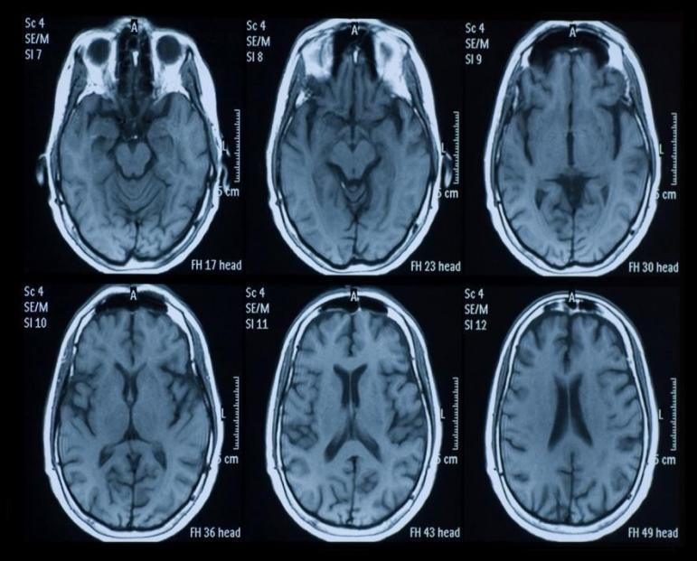

**Figure 1.1 Brain Tumor Images**

MRI images have different types depending on the method used to capture them, these types are called Modalities .Some tumor structures are visually clear in one modality more than the others. Also, MRI images do not produce radiations, so they are not harmful. MRI Image captured from different Angles reveals the detail areas inside the brain such as Axial, Sagittal and Coronal.

## 1.1 Brief

The human body consists of numerous numbers of cells. When cell growth becomes uncontrollable the extra mass of cell transforms into tumor.Brain tumor is caused by abnormality in cells of brain. There are 120 type of brain tumor exists and each tumor type has different size and location. So, it is very difficult task to classify the tumor part. Brain tumor treatment depends on doctor’s accurate decisions. These decisions are done by seeing and analyzing the tumor location in brain, tumor shape and tumor size. Doctors interpret the MRI of patient and decide that whether the patient has a tumor or not. Human errors can mislead to wrong diagnosing of tumor type and can be misleading for planning the treatment for patients.

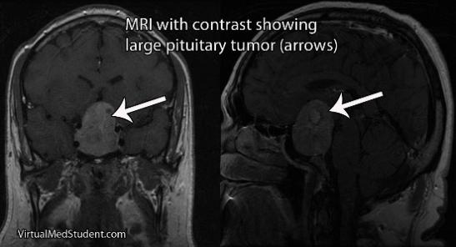

**Figure 1.2 Pituitary Tumor**

Diagnosis of tumor with the help of MRI image is mandatory but time-taking. This task is difficult for experts when they go for manual method. So, computer supported system are introduced for accurate is ease detection from MRI images.It is problematic for radiologists to detect the tumor types manually and make decision due to variation in size, shape, and types of abnormal tissues. This system reduces the workload and avoids the mistakes that can be done by the radiologist.

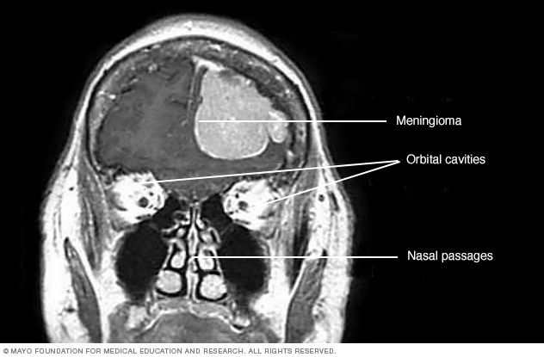

**Figure 1.3 Meningioma Tumor**

Therefore, these systems are playing vital role in diagnosing and detection of tumor automatically. Nowadays, the use of these systems supporting in the early detection of any type of tumor in recent years. By studying the literature, we have analyzed that system’s performance can be better by improving the computational speed and flexible systems for different brain data sets.

The proposed system works on four tumor and non-tumor types: meningioma, pituitary glioma, acoustic neuroma and no tumor MRI images**.**

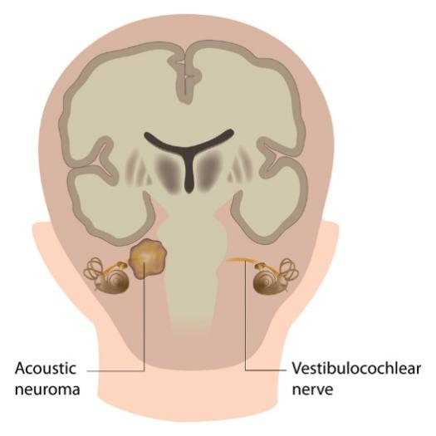

**Figure 1.4 Acoustic Neuroma**

## 1.2 Relevance to Course Modules

In Artificial Intelligence course all machine learning techniques and algorithms are part of it.The topic that closely relates with my project is neural network. An artificial neuron is developed by machine learning technique to replicate the biological neuron. Neural networks comprise of technologies like machine learning concepts and deep learning and form a part of Artificial Intelligence.

In Machine Learning course we have studied about different algorithms which are used to train models to perform task automatically after getting the training data.

A system which is interactive is easy and comfortable for the user to use the system and understand it easily and in Human Computer Interaction course is all about designing + interacting system following standard rules.

In Report Writing Skills course is about learning how to write reports and other formal documentation, and, in our project, it help us to write the project documentation.

## 1.3 Project Background

There are four categories of brain tumor i.e. meningioma, pituitary, glioma and acoustic neuroma and non-tumor images are also part of dataset. Meningioma tumor is developed in thin membranes of brain like around spinal cord. Pituitary tumor is developed in pituitary gland of brain. Glioma tumor develops in the substance of brain. For examining the tumor, the brain MRI is taken to detect the tumor and to diagnose it. Radiologists must examine these MRI images and they consume a lot of their time and energy in coming up with results. If a patient has last stage tumor then it is impossible to save the life because the manual method of detecting the brain tumor takes time. To get rid of this problem, an automated system is introduced which help radiologist in early detection of brain tumor and to save the precious lives of patients.

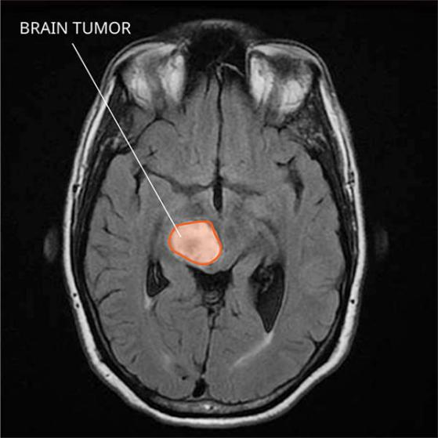

**Figure 1.5 Brain Tumor Location**

## 1.4 Literature Review

Different approaches have been used in past few decades for diagnosis.

## 1.4.1 Machine Learning Based Approaches

Machine Learning plays an important role in Computer Diagnosis system and give promising results with improved accuracy. The machine learning also ensure the analysis of the different medical data and machine learning also provide the ability to make classy and good algorithms that help in diagnosing. For examining the bio-medical data, machine learning provides a worthy approach for making efficient algorithms. Following are the approaches that have been proposed by researchers.

Dipali M. Joshi. [1] Proposed neural network approach for classification. In his work, the focus was to classify the tumor as well. He used astrocytoma tumor types for classification, using astrocytoma tumor he performed pre-processing method such as histogram, segmentation, morphological technique. His feature extraction method was Gray Level Co-occurrence Matrix (GLCM). The GLCM based features were then compared already stored features. After that, a Neuro Fuzzy method was developed for classification. Their classification approach required many steps for imagepre-processing and detection which increase the computational time.Also, high computing cost is the draw back that consumes high CPU and use of physical memory.

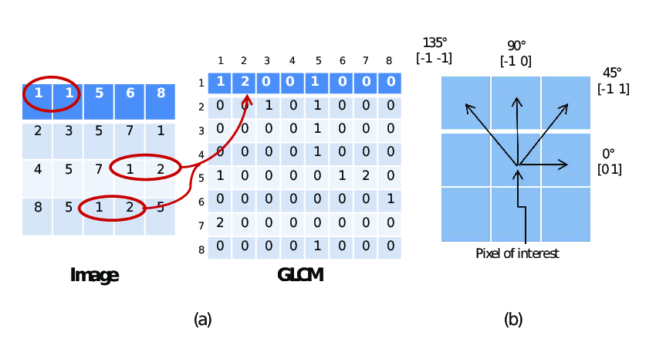

**Figure 1.6 GLCM**

In the research work proposed by Hari Babu Nandpuru. [2] and Dr. S. S. Salankar, classification algorithm is done using Support Vector Machines (SVM). They proposed brain image classification that use Feature extraction by applying grey scaling and two more features like symmetrical and texture. For diagnosis, they used 50 patient’s brain images with two classes such as ‘Normal’, 'Abnormal’ .Using on the SVM classification algorithm they classified the tumor type successfully.

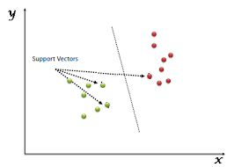

**Figure 1.7 Support Vector Machine**

[3] Used KNN classifier for classification purpose by going through following steps: Determining the k value, calculating distance between the training samples and query instance and, sortation of distance based on the kth minimum distance, majority class assignment, determining the class. Both and color features textural features are being passed in classification algorithms using K- NN give the accuracy of 87.0%. Their method was evaluated on categorized data as Normal Brain Images, Primary Tumor images (or benign), Secondary Tumor Images (or Malignant).

## 1.5 Analysis from Literature Review

Deep learning has a classifier named as Deep Neural Network (DNN) classifier that classifies four types of tumor classes. Overall accuracy is 96 %. Artificial Neural Network (ANN) classifier used astrocytoma tumor types for classification, using astrocytoma tumor. Their classification approach required many steps for image pre-processing and Detection which increase the computational time. The drawback was high computing cost for consuming much memory and resources. And low accuracy

Support Vector Machines (SVM) method used feature extraction by applying grey scaling and two more features like symmetrical and texture. K-Nearest Neighbor (KNN) classifier soused for this problem. This algorithm using K-NN give the accuracy of 87.0% and high computing cost.

## 1.6 Methodology and Software Lifecycle for this project

Project methodology is an important phase of any project because it is a key element and set the overall tone. For this we must first understand the steps that are involved in project methodology. We use iterative approach to develop this application.

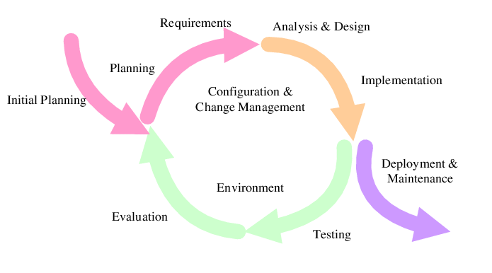**Figure 1.8 Iterative Model**

## 1.6.2 Rationale behind selected methodology

During implementation phase we may add, remove, or modify different features. So, an iterative development will be a good approach to achieve this. Furthermore, it allows:

* Working software creates speedily and early.
* This design is more workable– less costly to adjust specifications and dimensions.
* During iteration, testing and debugging is not hard and complex.
* The cost of delivery is reduced.
* Risk management is much simpler and easier because they are identified during each iteration.

# Chapter 2

# Problem Definition

# 2. Problem Definition

## 2.1 Problem statement

Our study deals with automated brain tumor detection and classification. Normally the anatomy of the brain is analyzed by MRI scans or CT scans. Our system aims to detect if the given MRI scan has a tumor and if found it then classifies the tumor as into its types. Our project deals with automated brain tumor classification. Normally the anatomy of the brain is analyzed by MRI scans. Our system aims to detect if the given MRI scan has a tumor and if found it then classifies the tumor as meningioma, glioma, and pituitary, acoustic neuroma And No tumor.

Classification of Brain Tumor is needed to overcome the manual analysis, workload, improve computational time, flexibility, and the accuracy. Brain tumor is expected to become the number one cause of death in future. There is large amount of brain tumor images to be process, multiple angles of MRI scan need to be analyzed and diagnosis. Sometimes human fatigue and stress can affect the process of analysis. Physicians sometime fail to detect the early signs. Existing computer aided diagnosing systems are not capable of generating efficient results in less computational time and inflexible to different brain data sets.

To accurately classify the brain type, we need accurate systems to accommodate the limitations. Solution to the problem is make software that early detect the tumor type automatically in brain. This will be helpful for radiologist and physicians for deciding the surgical treatment. Automatically classifying the tumor type whether it is meningioma,, acoustic neuroma , glioma or pituitary

## 2.2 Deliverables and Development Requirements

Following are the requirements to create our project:

* MRI images of meningioma, glioma, pituitary and acoustic neuroma brain tumor.
* MRI images of non-tumor of brain.

The list of deliverables consists of following:

* Desktop application
* Documentation

Development requirements include following software and hardware requirements:

* IDE: PyCharm
* Anaconda
* Dataset based work.
* Pytorch for Libraries
* Good GPU and 8 GB RAM system
* MS WORD
* Programming Language: Python
* Interface: PyQT Designer

# Chapter 3 Requirement Analysis

# 3. Requirement Analysis

System Requirements Specification (SRS) is an official statement for the application to provide functional and operational requirements .During the development process of system,it serves as contract between the developer and the customer for whom the system is being developed. The developer would be capable to build the system based on specified requirements as the enlists and necessary requirements specification for the system development is enough. SRS dependency based on functional and non-functional specifications and inclusion of use cases defining user experiences to be supported by software.

## 3.1 Use Case Diagram

A use case diagram is a technique utilized as a part of framework investigation to perceive and arrange framework necessities.We design UML(Unified Modelling Language) figures to model a framework in the simple and efficient way.

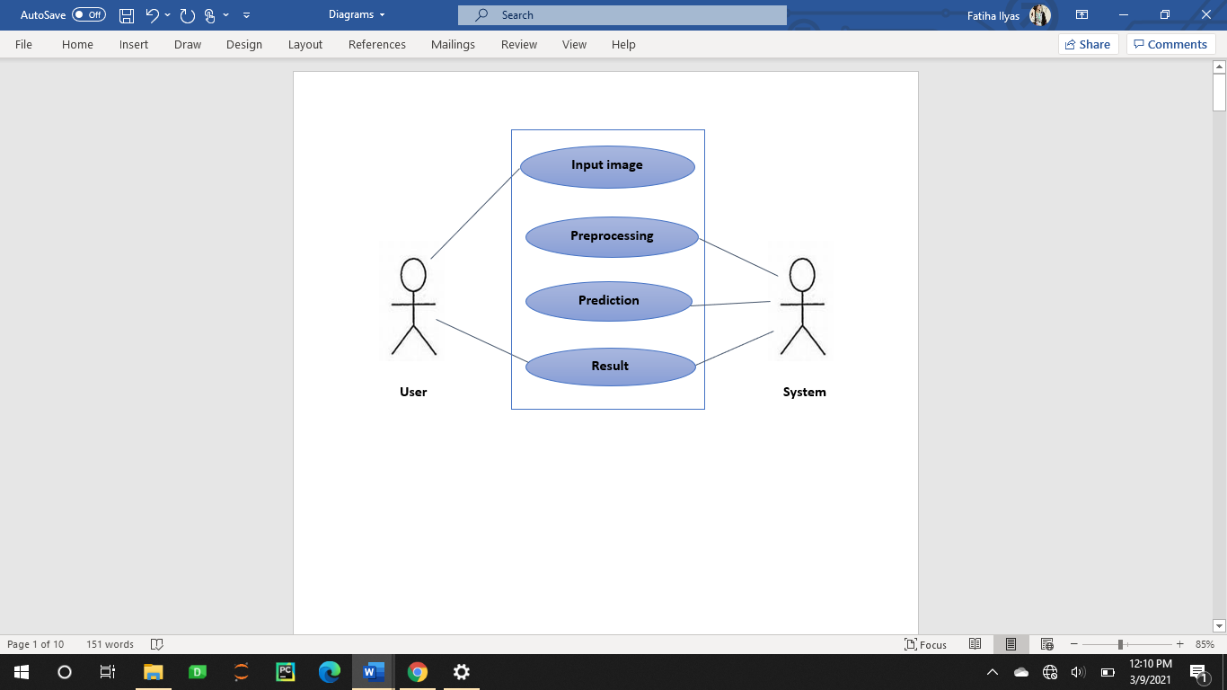

**Figure 3.1 Use Case Diagram**

## 3.2 Detail of Use Case Diagram

**Table 3‑1 Input image (Use Case Description)**

|  |  |
| --- | --- |
| **Use-case name** | **Input image** |
| **Action** | User |
| **Description** | User will input image from system directory to application as initial step to use this application. |
| **Pre-condition** | Images must be present in system directory. |
| **Post-condition** | After giving an input to a system, system must start pre-processing process. |

**Table 3‑2 Pre-Processing (Use Case Description)**

|  |  |
| --- | --- |
| **Use-case name** | **Pre-Processing** |
| **Action** | System |
| **Description** | User will input image for pre-processing. |
| **Pre-condition** | The User will upload MRI image from directory. |
| **Post-condition** | An input image must be preprocessed. |

**Table 3‑3 Prediction (Use Case Description)**

|  |  |
| --- | --- |
| **Use-case name** | **Prediction** |
| **Action** | System |
| **Description** | A preprocessed image is sent for predicting the result. |
| **Pre-condition** | An image must be preprocessed. |
| **Post-condition** | After prediction, result is shown. |

**Table 3‑4 Result (Use Case Description)**

|  |  |
| --- | --- |
| **Use-case name** | **Result** |
| **Action** | System |
| **Description** | Image label will be predicted. |
| **Pre-condition** | Image prediction has been done |
| **Post-condition** | Respond back to user. |

## 3.3 Functional Requirements

Functional requirement describes the predictable behavior of the framework. These are main framework requirement and without applying any of these requirements the framework should be fragmented.

* The system will take the input image.
* An input image is gone for preprocessing.
* A pre-processed image is gone for predicting the result.

## 3.3.1 Input Image

**Table 3‑5 FR-1 Input Image**

|  |  |
| --- | --- |
| Identifier | FR-1 |
| Title | Input image |
| Requirements | The system take image |
| Dependencies | None |

## 3.3.2 Pre-processing and Enhancement

Pre-processing and enhancement techniques are used to improve the detection of the suspicious region from Magnetic Resonance Image (MRI). This section presents the gradient - based image enhancement method for brain MRI images which is based on the first derivative and local statistics.The pre-processing and enhancement method consists of two steps;first the removal of film artifacts such as labels and X-ray marks are removed from the MRI using tracking algorithm. Second, the removal of high frequency components using weighted median filtering technique. It gives high resolution MRI compared to median filter, adaptive filter, and spatial filter.

Pre-processing is the first and essential part of the framework. Data cleaning is the basic step to refine data from noise, missing values, or irrelevant data. It is required for the removal of unwanted noisy datain the lesion image.We apply elements of pre-processing like,image scaling, color space transformation, contrast enhancement, image restoration and noise removal.

Pre-processing and enhancement techniques are used to improve the detection of the suspicious region from Magnetic Resonance Image (MRI). This section presents the gradient - based image enhancement method for brain MRI images which is based on the first derivative and local statistics. The pre-processing and enhancement method consists of two steps;first the removal of film artifacts such as labels and X-ray marks are removed from the MRI using tracking algorithm. Second, the removal of high frequency components using weighted median filtering technique. It gives high resolution MRI compared to median filter, adaptive filter, and spatial filter.

## 3.3.3 Prediction

It involves two steps merged in it i.e. feature extraction an d classification through classifier. Feature extraction is process of extracting quantitative information from an image such as color features, texture, shape, and contrast. Here, we have used Discrete Wavelet Transform (DWT) for extracting wavelet coefficients and Gray Level Co-occurrence Matrix (GLCM) for statistical feature extraction. Feature defines the behavior of image. To determine the subset of initial features is known as feature selection. Feature extraction refers to extraction of features based on pixels. To save the computational cost, take the tumor region and extract its features and interpret them. This is done to isolate desired portion from an input image.

In classification tasks,there are often several candidate feature extraction methods available.The most suitable method can be chosen by training neural networks to perform the required classification task using different input features (derived using different methods). The error in the neural network response to test examples provides an indication of the suitability of the corresponding input features (and thus method used to derive them) to the considered classification task.

Convolutional Neural Networks(CNNs)have proven to be very successful frameworks for image recognition. In the past few years, variants of CNN models achieve increasingly better performance for object classification.

**Table 3‑6 FR-2 Classifier CNN**

|  |  |
| --- | --- |
| **Identifier** | **FR-2** |
| **Title** | Classifier CNN |
| **Requirements** | The system performs the classification and predict the brain tumor label. |
| **Dependencies** | FR-1 |

## 3.3.4 Result

**Table 3‑7 FR-3 Output**

|  |  |
| --- | --- |
| **Identifier** | **FR-3** |
| **Title** | Result |
| **Requirements** | When prediction is done, the result is shown. |
| **Dependencies** | FR-2 |

## 3.4 Non-Functional Requirement

## 3.4.1 Performance

Performance of our system is efficient ,and it takes very less time to perform the action.Our CAD system saves the time.

## 3.4.2 Capacity

Our system must meet the agreed capacity.

## 3.4.3 Availability

The system will be available into any hospital or clinic.

## 3.4.4 Reliability

Our system is reliable and generates an accurate result.

## 3.4.5 Maintainability

Our system will be maintained properly and any feedback from the user is our priority while performing maintenance.

## 3.4.6 Efficiency

This system is efficient as it does not require any kind of effort to use it and does not take much time.

## 3.4.7 Flexibility

The system provides the user to load the image.

# Chapter 4

# Design and Architecture

# 4. Design and Architecture

After gathering all requirements, the next step is to start planning that how we are going to develop our project, how much resources, costs, time, benefits, and other items are required. After planning we move to the designing and architecture phase that which techniques and methods we can use and how we are going to develop our project. It is the most challenging phase of project development.

## 4.1 System Architecture

#### 

**Figure 4.1 System Architecture**

## 

## 4.2 Process flow (Representation)

## 4.2.1 Data Flow Diagram

A data flow diagram is graphical interpretation of information move from a data framework is called Data Flow Diagram (DFD).ADFD isused for basic step to create an overview of the system without going into great aspect, which can later be elaborated.

Now Data flow diagram can be drawn to show the different levels of abstractions .Levels in DFD are numbered as 0, 1 and soon.

#### 4.2.1.1 Level 0DFD

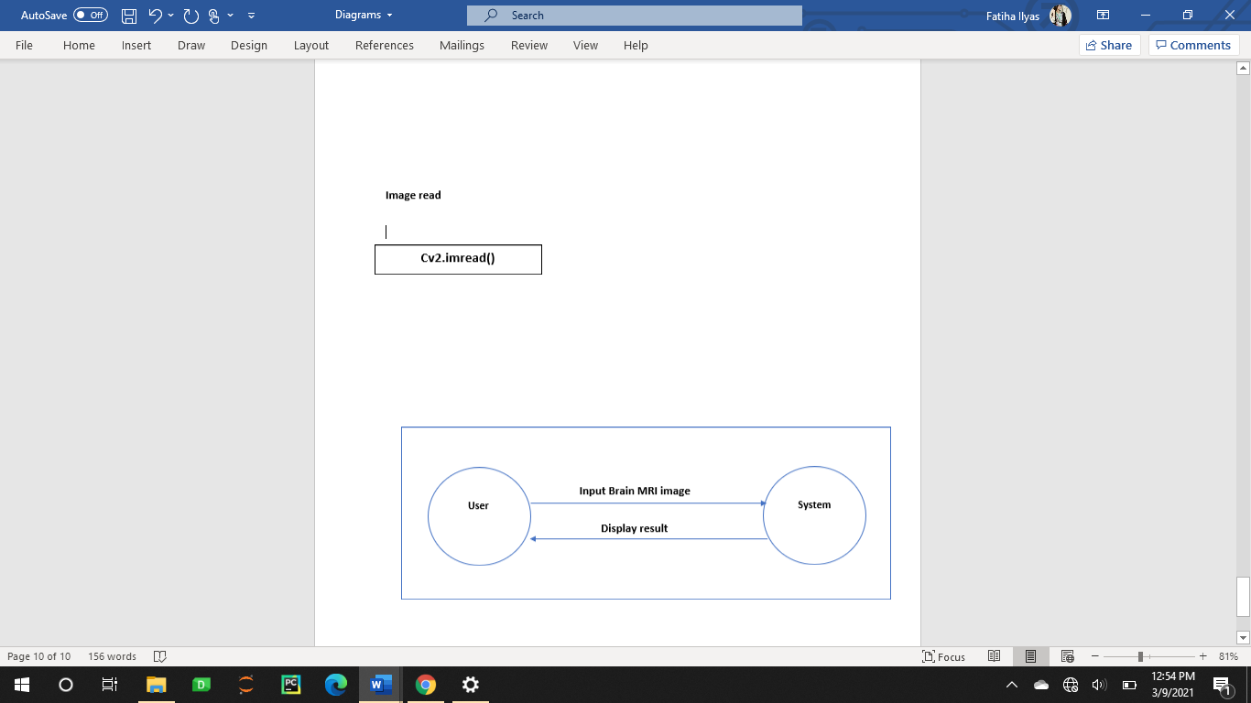

**Figure 4.2 DFD Level 0**

#### 4.2.1.2 Level 1DFD

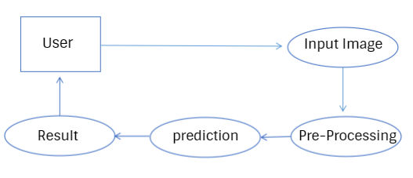

**Figure 4.3 DFD Level 1**

This presents the complete design of our project. Project design is an important part for developing a graphical view of requirement based on the detailed functional and non-functional requirements in the previous chapter. Project design is only acceptable and marked as good after understanding the requirements of the project provided for development. It is always good practice to start from making a high-level design and then move it to low-level design phases.

## 4.2.2 Activity Diagram

An activity diagram is depicting the dynamic component of the framework. An activity diagram is essentially a flowchart to speak from one action to another movement. The movement may be relating to an operation of the framework. This diagram is used to explain the dynamic features of the system. It is more like a flow chart because it shows the flow of data from one activity to other.

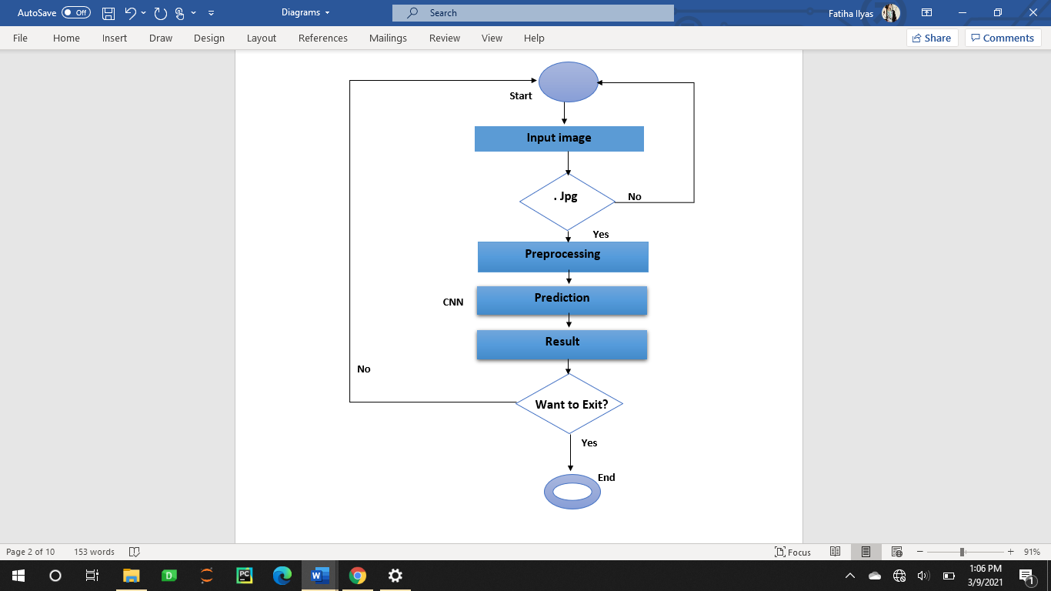

**Figure 4.4 Activity Diagram**

## 4.3 Design Models

## 4.3.1 Sequence Diagram

A cooperation graph that shows how objects work with each other and in what request is called sequence diagram. It is built up of message arrangement outline.

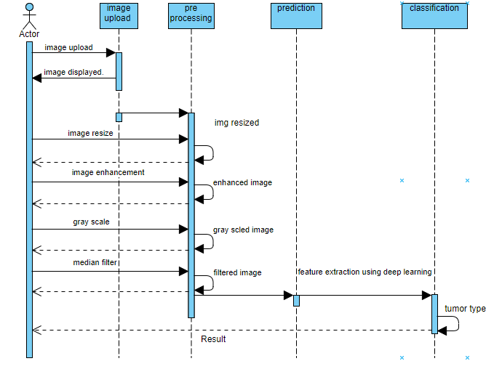

**Figure 4.5 Sequence Diagram**

## 4.3.2 Class Diagram

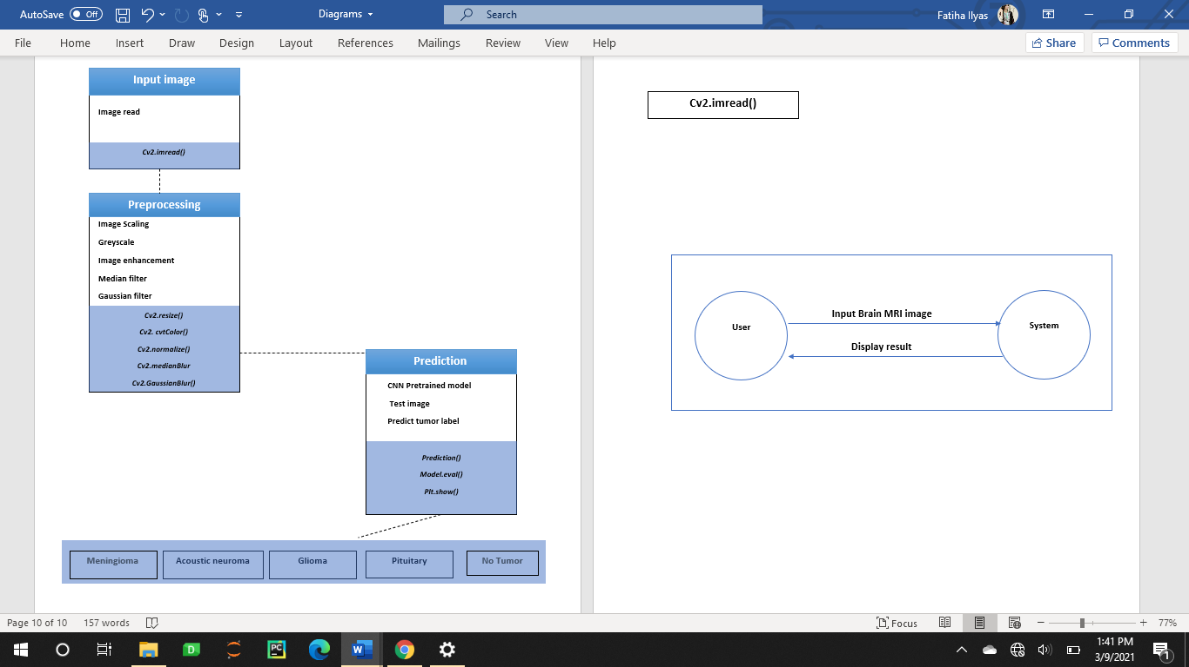

**Figure 4.6 Class Diagram**

# 

# Chapter 5

# Implementation

# 5. Implementation

An application is result of successful implementation of project – the various algorithms, testing approaches and the results.

## 5.1 Algorithm

## 5.1.1 Dataset

Four tumor classes and non-tumor images are included in the dataset which are Meningioma, Glioma, Pituitary and Acoustic Neuroma. The size of MRI image is 512 x 512 pixels.

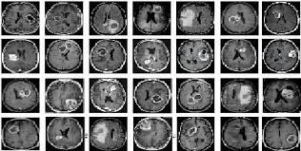

**Figure 5.1 Dataset**

## 5.1.2 Preprocessing

Image pre-processing means data should be clean and consistent. In this phase images are divided into testing and training and are stored in separate folders. We use 800 images for training from each tumor class and 200 images for testing the data.

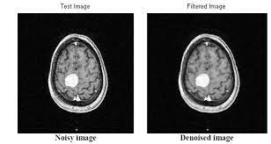

**Figure 5.2 Preprocessing**

Following techniques are applied to clean noise from images:

#### 5.1.2.1 Image Scaling

As the images are of different size so we need to rescale them in one standard size. We resized them into (64 * 64) because machine learning models learn faster on smaller images. All images are rescaled to (64 * 64) and model is trained over them.

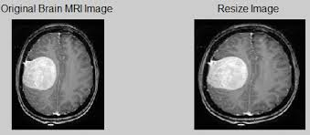

**Figure 5.3 Image Scaling**

#### 5.1.2.2 Grey Scale

It is done on an image because it takes less space in memory by minimizing the number of pixels that need to be processed.

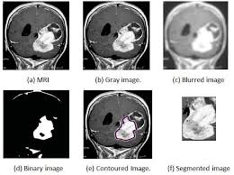

**Figure 5.4 Grey-Scaling**

#### 5.1.2.3 Image Enhancement

To enhance the image, normalization algorithm is done that controls the brightness and of pixels of an image.

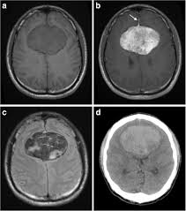

**Figure 5.5 Image Enhancement**

#### 5.1.2.4 Median Filter

It used to remove (impulse) “salt and pepper” noise quality of while preserving the edges sharp of greyscale image. It works by moving through the greyscale image pixel by pixel, replacing each value with the median value of neighboring pixels.

#### 5.1.2.5 Gaussian Filter

It used to produce blur in the image by gaussian function for removing gaussian noise. It does not preserve the edges sharp like median filter.

## 5.1.3 Prediction

#### 5.1.3.1 CNN Architecture

#### The architecture of CNN is implemented in that manner as follows:

##### *5.1.3.1.1 Convolution*

##### We used 2 convolutional layers in our model.

##### *5.1.3.1.2 Pooling*

##### We used 2 max pooling layers in our model.

***5.1.3.1.3 Fully connected.***

We used 2 fully connected layers in our model.

#### 5.1.3.2 Implementation

* **Input Dataset**

PyTorch library of python is used to load dataset in algorithm.

* **CNN Model**

Convolutional layers, max pooling and fully connected layers are used.

* **Training**

The images are divided into testing and training. We used 1100 images for training the data. All factors of training phase are achieved like updating of weights, loss error function and optimization of algorithm. This process continued. After training, the model we save the model with pyTorch (.PTH) file extension. The training is done in six epochs.

* **Testing**

We used 200 images for testing from each tumor classes. From pre-trained model, test images are evaluated, and classification is done.

* **Output**

When all steps are done, accuracies of all individual classes are displayed on GUI screen.

**Table 5‑1 Accuracies**

|  |  |  |  |
| --- | --- | --- | --- |
| **Labels** | **Tumor class** | **Accuracy** | **Overall accuracy** |
| 1 | Meningioma | 92.42% | 94% |
| 2 | Glioma | 96 % |
| 3 | Pituitary | 98.50% |
| 4 | Acoustic Neuroma | 90% |  |
| 5 | No Tumor | 91% |  |

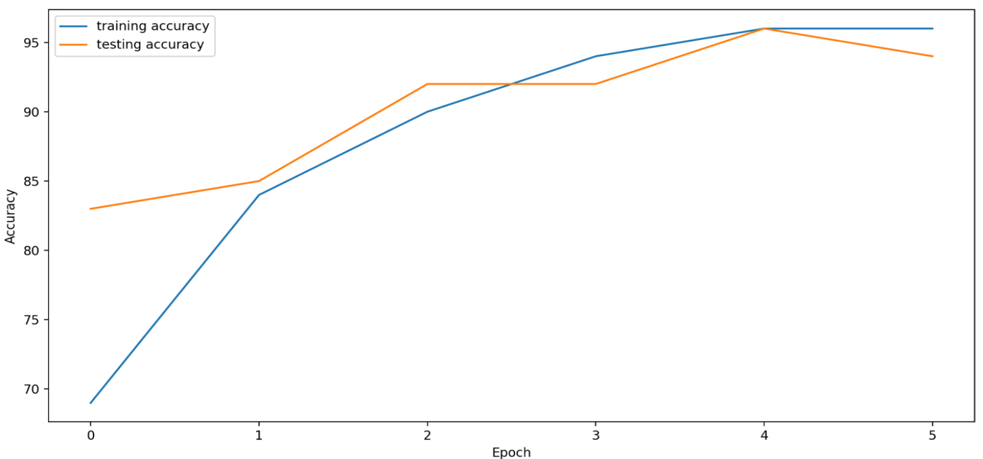

**Figure 5.6 Graph Accuracy**

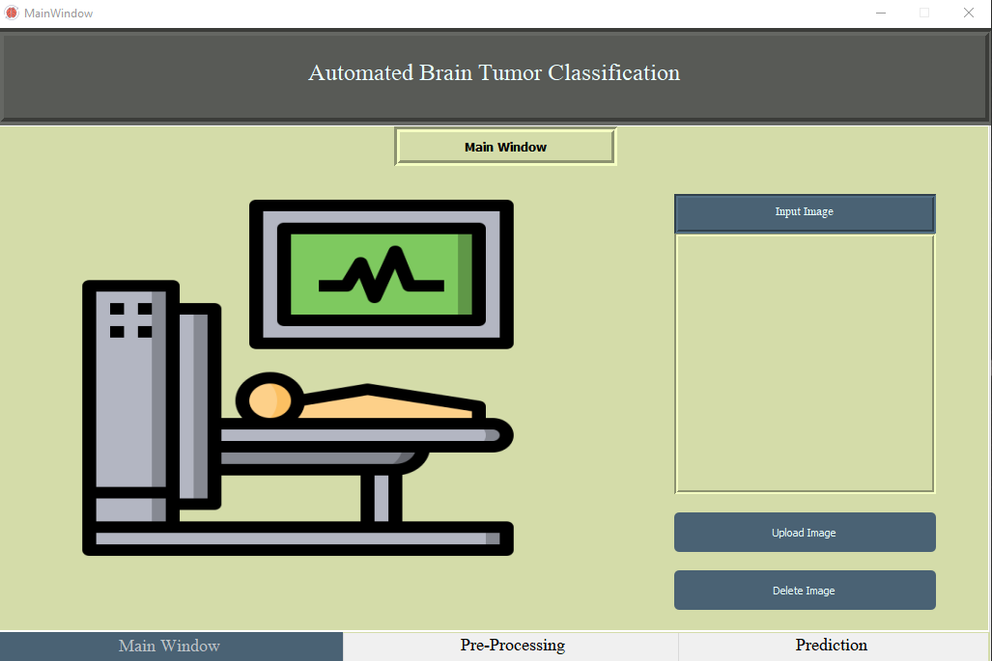

## Interface

**Figure 5.7 GUI (1)**

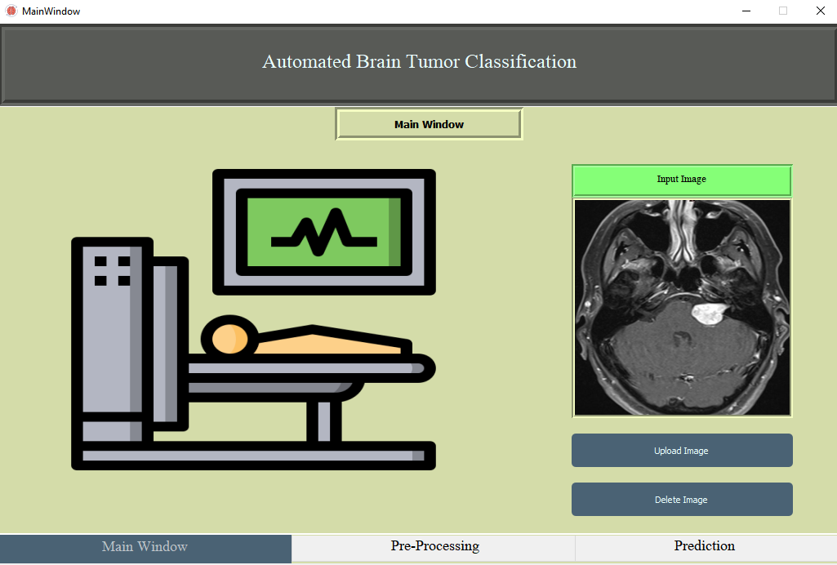

**Figure 5.8 GUI(2)**

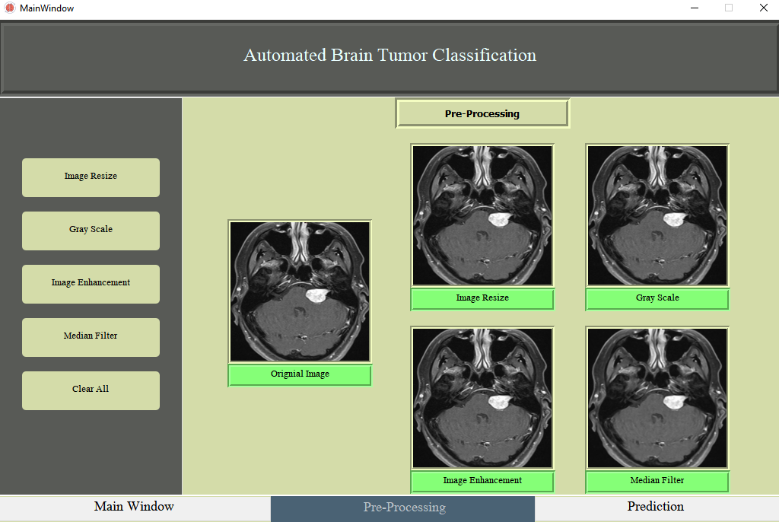

**Figure 5.9 GUI(3)**

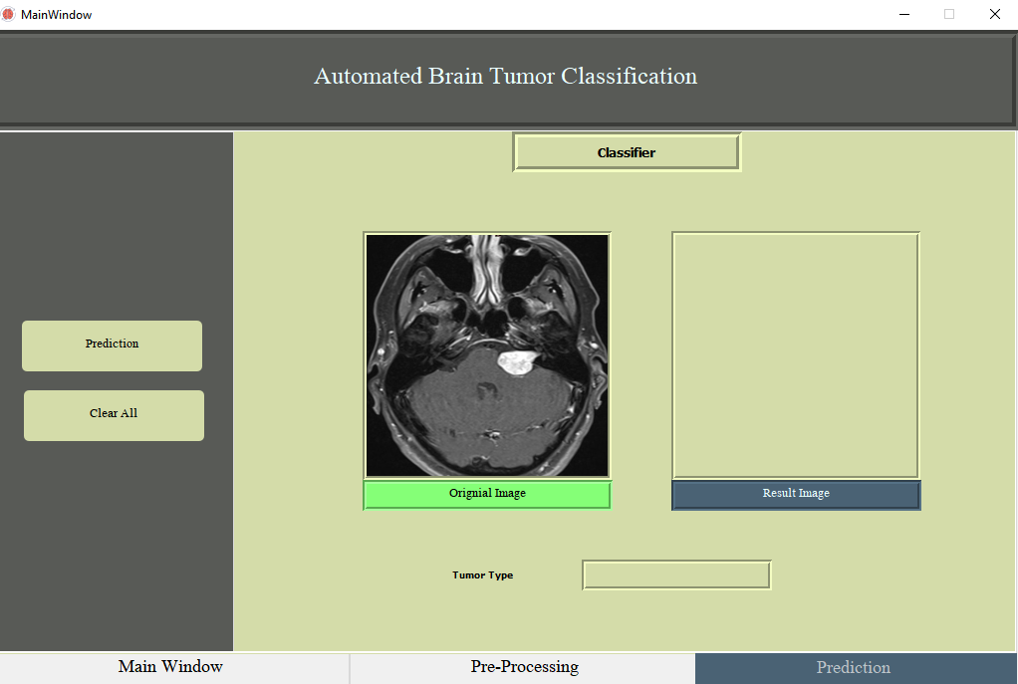

**Figure 5.10 GUI(4)**

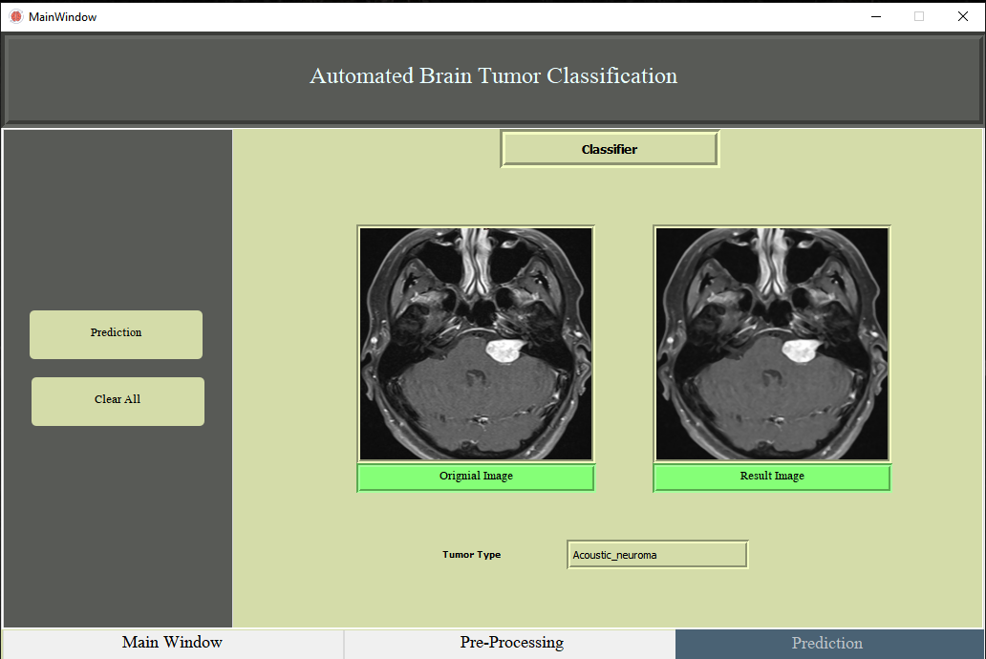

**Figure 5.11 GUI(5)**

# Chapter 6

# Testing and Evaluation

# 6. Testing and Evaluation

Once the system has been successfully developed, testing and evaluation has to be performed to ensure that the system working as intended. This is also to check that the system meets the requirements stated earlier. Besides that, system testing will help in finding the errors that may be hidden from the user.

## 6.1 Manual Testing

In this type of testing, whole system is tested manually without aid of any tool. It’s the first ever testing done on the system after implementation. All lines of code are checked and if any error or bug appears then it is fixed. The needs of radiologists are note down in the start and during manual testing all the requirements are cross matched whether the system deliver the correct output or not.

## 6.1.1 System Testing

In this type of testing, all the functions of an application are checked whether it is properly integrated or not. When backend coding is linked to frontend or Graphical User Interface (GUI) then whether it function smooth or not. The brain tumor image is given as input to system and the image pass through all functions and result is evaluated.

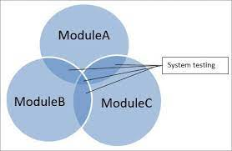

**Figure 6.1 System Testing**

## 

## 6.1.2 Unit Testing

In unit testing, all units of our system are tested and checked whether the system is according to the user needs or not.

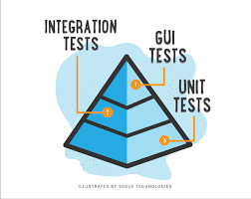

**Figure 6.2 Unit Testing**

#### 6.1.2.1 Input image

When the button ‘*Input image*’ is clicked then it opens the image directory. Any image from directory can be selected and uploaded on graphical user interface. The format of image must be .jpg format.

#### 6.1.2.2 Preprocessing

Five buttons named as *‘image scaling’*, ‘*grey scale’*, ‘*image enhancement’*, ‘*median filter*’ and ‘*gaussian filter*’ are clicked in any order and image is free from noise. The format must be .jpg format.

#### 

#### 6.1.2.3 Prediction

When ‘*prediction*’ button is clicked, test image is compared with the trained model and result is predicted. The output image is in .jpg format.

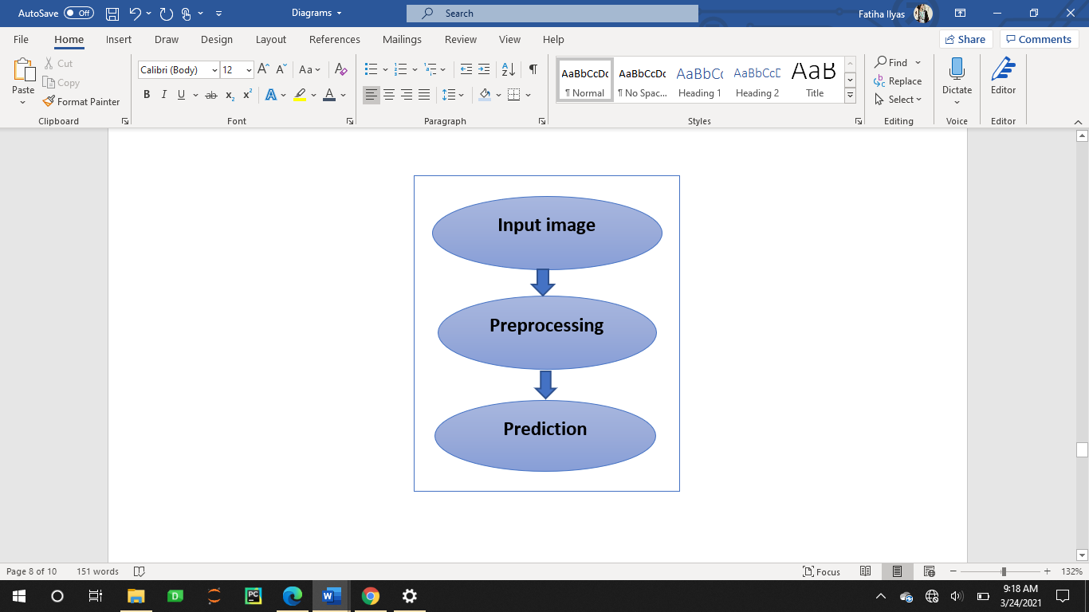

**Figure 6.3 Units of Project**

## 6.1.3 Functional Testing

For functional testing, we generate the test cases.

#### Test Case 1

**Table 6‑1 Input image**

|  |  |  |  |  |
| --- | --- | --- | --- | --- |
| **No.** | **Test case** | **Attribute and value** | **Expected result** | **Result** |
| 1 | Input image | Image is input from directory. | Image is displayed. | Image displayed. |

#### Test Case 2

**Table 6‑2 No image uploads**

|  |  |  |  |  |
| --- | --- | --- | --- | --- |
| **No.** | **Test case** | **Attribute and value** | **Expected result** | **Result** |
| 2 | No Image uploads. | If button pressed without image upload | Error message. | Error message. |

#### Test Case 3

**Table 6‑3 Preprocessing**

|  |  |  |  |  |
| --- | --- | --- | --- | --- |
| **No.** | **Test case** | **Attribute and value** | **Expected result** | **Result** |
| 1 | Image Scaling | Test image present in folder | Image scaled and displayed | Image scaled and displayed |
| 2 | Greyscale | Test image present in folder | Image displayed | Image greyscale and displayed |
| 3 | Image Enhancement | Test image present in folder | Image displayed | Image enhanced and displayed |
| 4 | Median Filter | Test image present in folder | Image displayed | Image noise removed and displayed |
| 5 | Gaussian Filter | Test image present in folder | Image displayed | Image noise removed and displayed |

#### Test Case 4

**Table 6‑4Prediction**

|  |  |  |  |  |
| --- | --- | --- | --- | --- |
| **No.** | **Test case** | **Attribute and value** | **Expected result** | **Result** |
| 6 | Prediction | Input image matched with trained load model. | Predicted the tumor label | Image label predicted |

#### Test Case 5

**Table 6‑5 No Tumor**

|  |  |  |  |  |
| --- | --- | --- | --- | --- |
| **No.** | **Test case** | **Attribute and value** | **Expected result** | **Result** |
| 7 | No Tumor | Any image presented | No tumor label predicted | Prediction not successful. |

## 

## 6.1.4 Integration Testing

**Table 6‑6 Integration Testing**

|  |  |  |  |  |
| --- | --- | --- | --- | --- |
| **No.** | **Test case** | **Attribute and value** | **Expected result** | **Result** |
| 1 | Input image | Image from folder to know recognized tumor. | Selected image is displayed. | Selected image displayed |
| 2 | No image uploads | If button of any operation pressed. | Error message | Error message |
| 3 | Pre-processing | Result image present in folder. | All operation buttons are pressed. | Image preprocessed successfully. |
| 4 | Prediction | Input image matched with trained load model. | Predict the label of image. | Image predicted successfully. |
| 5 | No Tumor MRI | Any image presented. | The tumor label predicted | Prediction not successful. |

## 

## 6.2 Automated Testing

We only performed manual testing.

## 

## 6.3 Tools

**Table 6‑7 Tools**

|  |  |  |  |
| --- | --- | --- | --- |
| **Tool Name** | **Tool Description** | **Applied on [list of related tests cases / FR / NFR]** | **Results** |
| PyCharm | JetBrains PyCharm Community Edition 2019.2.1 | All test cases. | Code |
| Anaconda distribution | Anaconda3-2019.10-Windows-x86_64 | All test cases | Libraries |
| PyQt Designer | Comes from library of python, PyQt5. | Used for designing interface. | Frontend |
| Pytorch | Python library module | All test cases. | Libraries. |
| Microsoft Word | WORD 2016 | Used for documentation. | Documentation |
| Microsoft PowerPoint | POWERPOINT 2016 | Used for presentation slides. | Presentation |

# Chapter 7

# Conclusion and Future Work

# 

# 7. Conclusion and Future Work

## 7.1 Conclusion

Abnormal growth of tissue in the brain become tumor which can affect the normal functioning of brain the goal of image processing and machine learning in the medical field is to obtain the meaningful information with least human error accuracy and reliability are of utmost important two factor in tumor diagnosis because patient’s life depends upon the prediction by the system In our project we have developed open source software to distinguish four types of brain tumor and one non tumor type. We are working on GUI, which is user friendly. It consists of seven steps, namely Input image, preprocessing (‘*image scaling’*, ‘*grey scale’*, ‘*image enhancement’*, ‘*median filter*’ ) and prediction. We used Convolutional Neural Network to train our model and then the testing image is matched with trained model to predict the result as CNN does not require region segmentation even without segmentation CNN returns good result and accuracy . Here several methodologies are existing for brain tumor detection of MRI image. But this method is fast, and efficient

We acquired 94% accuracy overall in concluding the four types of brain tumor and one non tumor type

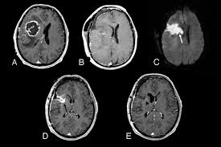

**Figure 7.1 Conclusion**

7.2 Future Work

In the future, the actual implementation of the project will be done where all the modules will be coded, tested, and deployed at industrial level.Multiple brain tumor exist in the world more tumor classes can be added and overall accuracy of the system can be improved .With more extended data set the over all classification accuracy can be improved There are so many algorithms available for prediction and image processing, Graphical comparison of abnormal and normal brain can be added in to the system. This system can be used in clinics which can replace the manual reading of MRI images for brain tumor detection , it can save time and this process is less prone to human error which can be helpful for doctor to take better decision for the treatment of patient

# 

# Chapter 8

# References

[1] D. M. Joshi, N. K. Rana and V. M. Misra, "Classification of Brain Cancer using Artificial Neural Network," *2010 2nd International Conference on Electronic Computer Technology*, Kuala Lumpur, 2010, pp. 112-116, doi: 10.1109/ICECTECH.2010.5479975.

[2] Hari Babu Nandpuru, S. S. Salankar and V. R. Bora, "MRI brain cancer classification using Support Vector Machine," *2014 IEEE Students' Conference on Electrical, Electronics and Computer Science*, Bhopal, 2014, pp. 1-6, doi: 10.1109/SCEECS.2014.6804439.

[3] Singh, S. “CLASSIFICATION OF HUMAN BRAIN TUMORS FROM MRI USING K-NN ALGORITHM.” (2015).

[4] T. Logeswari, M. Karnan, “*An improved implementation of brain tumor detection using segmentation based on hierarchical self-organizing map***”,** Int J Comput Theory Eng, 2 (4) (2010), pp. 591-595.

[5] K.B. Ahmed, L.O. Hall, D.B. Goldgof, R. Liu, R.A. “*Fine-tuning convolutional deep features for MRI based brain tumor classification Medical Imaging*” 2017: Computer-Aided Diagnosis, Vol. 10134, International Society for Optics and Photonics (2017 Mar 3), p. 101342E.

[6] Cheng J, Yang W, Huang M, Huang W, Jiang J, Zhou Y, et al. (2016) Retrieval of Brain Tumors by Adaptive Spatial Pooling and Fisher Vector Representation. PLoS ONE 11(6): e0157112 <https://doi.org/10.1371/journal.pone.0157112>.

[7] Abiwinanda N., Hanif M., Hesaputra S.T., Handayani A., Mengko T.R. (2019) Brain Tumor Classification Using Convolutional Neural Network. In: Lhotska L., Sukupova L., Lacković I., Ibbott G. (eds) World Congress on Medical Physics and Biomedical Engineering 2018. IFMBE Proceedings, vol 68/1. Springer, Singapore.

[8] Justin S. Paul, Andrew J. Plassard, Bennett A. Landman, and Daniel Fabbri "Deep learning for brain tumor classification", Proc. SPIE 10137, Medical Imaging 2017: Biomedical Applications in Molecular, Structural, and Functional Imaging, 1013710 (13 March 2017); doi: 10.1117/12.2254195;https://doi.org/10.1117/12.2254195.

[9] Cheng J, Huang W, Cao S, Yang R, Yang W, et al. (2015) Correction: Enhanced Performance of Brain Tumor Classification via Tumor Region Augmentation and Partition. PLOS ONE 10(12): e0144479.

[10] A.R. Kavitha, L. Chitra, R. kanaga, “*Brain tumor segmentation using genetic algorithm with SVM classifier***”,** Int J Adv Res Electr Electron Instrum Eng, 5 (3) (2016), pp. 1468-1471.

[11] JaiSingh, W. & Nanjundan, Preethi. (2019). “*An Investigation on Brain Tumour Segmentation using Various Machine Learning Approaches*”. International Journal of Computer Sciences and Engineering. 7. 600-603. 10.26438/ijcse/v7i5.600603.

[12] V. Das, J. Rajan, “*Techniques for MRI brain tumor detection: a survey***”,** Int J Res Comput Appl Inf Tech, 4 (3) (2016), pp. 53-56

[13]G. Litjens, T. Kooi, B.E. Bejnordi, A.A. Setio, F. Ciompi, M. Ghafoorian, *et al.,”A survey on deep learning in medical image analysis,* Med Image Anal, 42 (2017), pp. 60-88

[14] Y. Pan, W. Huang, Z. Lin, W. Zhu, J. Zhou, J. Wong, *et al., “Brain tumor grading based on neural networks and convolutional neural networks*”, Engineering in medicine and biology society (EMBC), 37th annual international conference of the IEEE (2015), pp. 699-702

[15] D. Ravì, C. Wong, F. Deligianni, M. Berthelot, J. Andreu-Perez, B. Lo, *et al. “Deep learning for health informatics* “, IEEE J Biomed Health Inf, 21 (1) (2017), pp. 4-21

[16] A. Anuse, V. Vyas, “*A novel training algorithm for convolutional neural network*” Contr Intell Syst, 2 (3) (2016), pp. 221-234.

[17] Heba Mohsen, El-Sayed A. El- Dahshan, El- Sayed M. El- Horbaty, Abdel-Badeeh M.Salem, “*Classification using deep learning neural networks for brain tumors*,” Future Computing and Informatics Journal, Volume 3, Issue 1, June 2018, Pages 68-71, ISSN 2314-7288,

https://doi.org/10.1016/j.fcij.2017.12.001.

[18] Sonu Suhag, Lalit Mohan Saini, “*Automatic brain tumor detection and classification using svm classifier***”** Proceedings of ISER 2nd international conference, Singapore (July 2015), pp. 55-59.







